Title: Agriculture AI for smart farming Abstract
Agriculture plays a vital role in ensuring food security and sustainable development.
Traditional farming methods often rely on manual monitoring and experience, making it difficult to accurately predict crop diseases, irrigation requirements, and yield. This project proposes an Agriculture AI for Smart Farming framework that utilizes Machine Learning techniques to support farmers in making informed decisions and improving agricultural productivity.

The proposed system collects agricultural data such as soil moisture, temperature, humidity, rainfall, soil nutrients, and crop health information. Data preprocessing techniques are applied to remove missing values and normalize the dataset. Machine Learning algorithms such as Random Forest, Decision Tree, Support Vector Machine (SVM), and XGBoost are trained to predict crop diseases, recommend suitable crops, estimate irrigation needs, and forecast crop yield. The framework can also integrate weather information to provide timely farming recommendations.

The performance of the proposed model is evaluated using Accuracy, Precision, Recall, F1-Score, Mean Absolute Error (MAE), Root Mean Square Error (RMSE), and Confusion Matrix, depending on the prediction task. The resulting system aims to improve crop productivity, reduce water wastage, minimize disease outbreaks, and support sustainable farming practices through intelligent and data-driven decision-making.

Datasets

Dataset | URL link
Crop Recommendation Dataset | https://huggingface.co/datasets/THUDM/Crop_recommendation
PlantVillage Classification | https://huggingface.co/datasets/keremberke/plantvillage-classification
PlantVillage | https://huggingface.co/datasets/timm/plantvillage

Approach

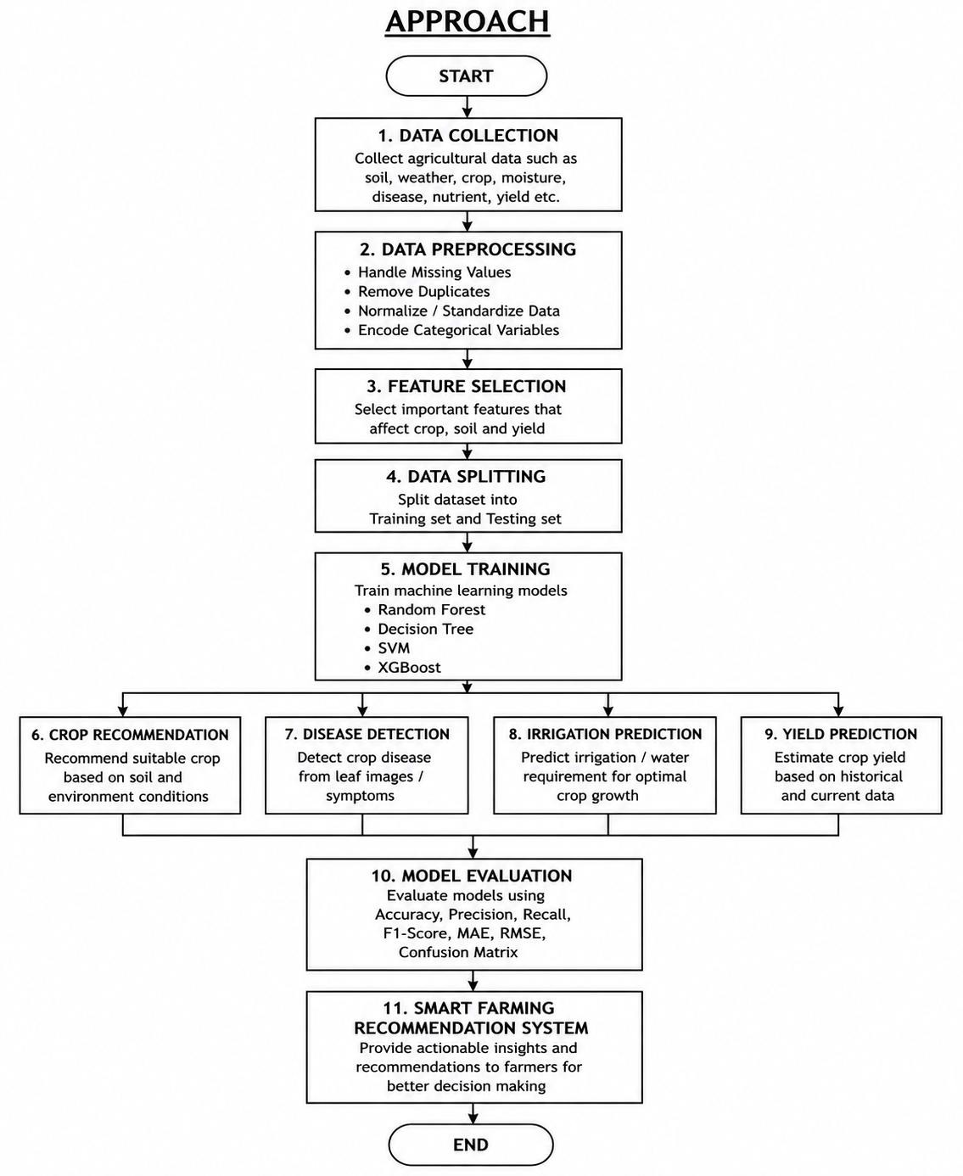

Project Group Members

S.No. | Roll.No. | Student Name
1 | 2420090001 | Ch.Surya
2 | 2420090037 | V.Rithvik
3 | 2420030628 | P.Akshaya
4 | 2420030601 | B.Niharika

